# TITLE PAGE

**DESIGN AND IMPLEMENTATION OF STUDENT PROJECT ALLOCATION AND management SYSTEM (cASE STUDY OF COMPUTER SCIENCE DEPARTMENT)**

**BY**

**IYA AISHA DIGIL**

**(ST/CS/ND/21/124)**

**DEPARTMENT OF COMPUTER SCIENCE,**

**SCHOOL OF SCIENCE AND TECHNOLOGY,**

**FEDERAL POLYTECHNIC, MUBI, ADAMAWA STATE.**

**IN PARTIAL FULFILLMENT OF THE REQUIREMENT FOR THE AWARD OF NATIONAL DIPLOMA (ND) IN COMPUTER SCIENCE.**

**SEPTEMBER, 2023**

# DECLARATION

I hereby declare that the work in this project titled “**Design and Implementation of Student Project Allocation and Management System (Case Study of Computer Science Department)”** was performed by me under the supervision of Mr. Musa Simon. The information derived from literatures has been duly acknowledged in the text and a list of references provided. The work embodied in this project is original and had not been submitted in part or in full for any other diploma or certificate of this or any other institution.

IYA AISHA DIGIL ________________ _______________

(ST/CS/ND/21/124) Signature Date

# CERTIFICATION

This project titled “**Design and Implementation of Student Project Allocation and Management System (Case Study of Computer Science Department)”** meets the regulations governing the award of National Diploma (ND) in Computer Science, Federal Polytechnic Mubi, Adamawa State

Mr. Musa Simon __________________

(Project Supervisor) Sign/Date

Mr. Mustapha Kassim. __________________

(Head of Department) Sign/Date

Mal. Abdulrahman Saidu _________________

(External Examiner) Sign/Date

# DEDICATION

This project is dedicated to my beloved parents for their advice, encouragement and financial support towards my academic pursuit.

# ACKNOWLEDGEMENTS

I want to acknowledge Almighty God for his infinite mercy and protection throughout my academic activities. And for the understanding in achieving our academic success.

I also recognize my Supervisor Mr. Musa Simon who took time, despite his busy schedule to direct and guide me throughout this research work.

I also acknowledge the Head of Department Computer Science Mr. Mustapha Kassim for his moral encouragement throughout my period of study. I also acknowledge all Staff of Computer Science Department for their support and encouragement and the knowledge they’ve impacted on me throughout my studies.

I also want to appreciate my lovely parents for their love and care and for giving me the opportunity to be trained and achieve my dreams.

Finally, I appreciate the efforts of my Uncles and aunties, for their encouragement and support throughout the course of my study and also my friends and relatives, course mates and all well-wishers. I love you all, may the Almighty God bless you abundantly, Amen.

# TABLE OF CONTENTS

TITLE PAGE i

DECLARATION ii

CERTIFICATION iii

DEDICATION iv

ACKNOWLEDGEMENTS v

TABLE OF CONTENTS vi

LIST OF FIGURES viii

LIST OF TABLES ix

ABSTRACT x

CHAPTER ONE 1

INTRODUCTION 1

1.1 Background to the Study 1

1.2 Problem Statement 2

1.3 Aim and Objectives 3

1.5 Scope of the Study 4

1.6 Definition of Some Operational Terms 4

CHAPTER TWO 5

LITERATURE REVIEW 5

2.1 Introduction 5

2.2 Project Management Systems in Academic Institutions 5

2.3 Project Allocation Algorithms 6

2.4 Benefits of Project Management Systems in Academic Institutions 7

2.5 Management Information System 8

2.6 Record Management System 9

2.7 Database Management System 10

SYSTEM ANALYSIS AND DESIGN 12

3.1 Introduction 12

3.2 Disadvantages of the Existing System 12

3.3 Advantages of the Proposed System 12

3.4 The Proposed Method 12

3.5 Methods of Data Collection 13

3.6 System Design 13

3.6.1 Algorithm diagrams 13

3.6.2 System Architecture 14

3.6.3 Database Tables/Queries Structures 14

3.6.4 The Input and Output Design 15

3.7 System Requirement Specification 17

3.7.1 Hardware Requirements 17

3.7.2 Software Requirements 17

3.7.3 Personnel Requirements 17

CHAPTER FOUR 18

RESULTS AND DISCUSSION 18

4.1 Introduction 18

4.2 Results 18

4.3 Discussion 20

4.4 User manual 21

CHAPTER FIVE 22

SUMMARY, CONCLUSION AND RECOMMENDATIONS 22

5.1 Summary 22

5.2 Conclusion 22

5.3 Recommendations 22

5.4 Contribution to Knowledge 22

5.5 Area for Further Work 23

# LIST OF FIGURES

Figure 3.1: Use Case Diagram - - - - - - - 13

Figure 3.2: System Architecture - - - - - - - 14

Figure 3.3: Log in form - - - - - - - - 15

Figure 3.4: Search Project - - - - - - - - 15

Figure 3.5: Add Project Topic - - - - - - - 16

Figure 3.6: Add Student Form - - - - - - - 16

Figure 4.1: Welcome Interface - - - - - - - 18

Figure 4.2: Login page interface - - - - - - - 18

Figure 4.3: Add Student interface - - - - - - - 19

Figure 4.4: Register project topic - - - - - - - 19

Figure 4.5: Registered project topics - - - - - - - 20

Figure 4.6: Registered students interface - - - - - - 20

# LIST OF TABLES

Table 3.1: Add Project Table - - - - - - - - 14

Table 3.2: Project topic table - - - - - - - - 14

Table 3.3: Add Student table - - - - - - - - 15

# *****ABSTRACT*****

*The "Design and Implementation of Student Project Allocation and Management System (Case Study of Computer Science Department)" represents a significant breakthrough in the realm of academic project allocation and management. This system is meticulously crafted to streamline and enhance the process of assigning, tracking, and managing student projects within the Computer Science Department, offering improved efficiency, transparency, and academic excellence. This innovative system provides a user-friendly platform that benefits both students and departmental faculty, simplifying project allocation, progress monitoring, and collaborative efforts. By successfully implementing this system, the Computer Science Department serves as a beacon of technological innovation in academic administration, exemplifying the transformative potential of technology in optimizing project management, fostering student growth, and ensuring administrative efficiency. This abstract offers a glimpse into the profound impact of the "Student Project Allocation and Management System," underscoring the power of technology to revolutionize project management within academic institutions and create an environment conducive to academic excellence and streamlined administrative operations.*

# CHAPTER ONE

# INTRODUCTION

## 1.1 Background to the Study

In today's rapidly evolving technological landscape, project management plays a crucial role in ensuring the successful completion of various endeavors. This is especially true in academic institutions, where project-based learning and research activities are prevalent. Efficiently managing student projects and allocating resources in departments such as computer science is vital for maximizing productivity and fostering a conducive learning environment. The increasing complexity of academic projects and the need for effective project management in educational institutions have driven the development of various project management systems. These systems aim to streamline project allocation, resource management, and progress tracking, ultimately improving the overall project outcomes. In the context of the computer science department at Federal Polytechnic, Mubi, the implementation of a Student Project Management and Allocation System (SPMAS) holds great potential for enhancing efficiency and student learning experiences.

Recent research in the field of computer science education has highlighted the importance of project-based learning and its positive impact on student engagement, critical thinking, and problem-solving skills (Crouch & Mazur, 2021; Guzdial, 2018). Project-based learning allows students to apply theoretical concepts to real-world scenarios, promoting a deeper understanding of the subject matter and fostering creativity. However, without an efficient project management system, the benefits of project-based learning can be hindered by administrative challenges and resource allocation issues. The existing manual systems for project management and allocation in computer science department suffers from several drawbacks. These include time-consuming administrative processes, subjective project assignment decisions, and a lack of transparency in the project allocation process. Additionally, manual systems often struggle to match student preferences, skills, and availability with project requirements, leading to suboptimal project outcomes.

To address these challenges, researchers and practitioners have focused on developing automated project management systems that can optimize project allocation processes and improve resource utilization. These systems leverage algorithms and data analysis techniques to match students with appropriate projects, considering factors such as student preferences, skills, project requirements, and resource availability. By automating project management tasks, these systems free up valuable time for faculty members and administrators, enabling them to focus on mentoring and guiding students throughout the project lifecycle.

Recent studies have showcased successful implementations of project management systems in various academic settings. For example, Bala *et al.* (2020), proposed a project management system that utilized data mining techniques to analyze student profiles and project attributes, resulting in improved project allocations. Another study by Chen *et al.* (2021), presented a web-based project management platform that integrated project proposal submission, allocation, and progress tracking features, facilitating seamless collaboration between students and faculty members.

Overall, these recent developments in project management systems have demonstrated the potential for enhancing project-based learning experiences and optimizing resource allocation in academic institutions. By leveraging automated allocation algorithms and web-based interfaces, a Student Project Management and Allocation System tailored to the computer science department at Federal Polytechnic, Mubi can address the limitations of the existing manual system and pave the way for improved project outcomes and student engagement.

## 1.2 Problem Statement

The computer science department, Federal Polytechnic, Mubi currently faces several challenges in managing student projects effectively. The existing manual system for project allocation and management suffers from the following limitations:

Time-consuming processes: The manual project management system requires significant administrative effort and time to handle tasks such as collecting project proposals, reviewing student preferences, and manually assigning projects to students. This inefficiency not only burdens faculty members but also delays the project allocation process, impacting the timely initiation of student projects.

Subjective project assignment: The manual system heavily relies on subjective decision-making by faculty members, which may introduce biases or inconsistencies in project allocation. Without a standardized and transparent process, students may feel that their preferences and skills are not adequately considered, leading to decreased motivation and engagement.

Inefficient resource allocation: The manual system lacks the capability to efficiently allocate resources such as facilities, equipment, and mentors within the department. As a result, resource conflicts may arise, leading to project delays, insufficient mentorship, and suboptimal utilization of departmental resources.

Lack of transparency: The absence of a centralized and transparent project allocation system makes it challenging for students and faculty members to track the progress of project assignments. Students often remain unaware of the status of their project requests or the allocation criteria used, making it difficult for them to plan and prepare for their assigned projects.

To address these limitations and improve the overall project management process, there is a clear need for a comprehensive Student Project Management and Allocation System (SPMAS) that automates and streamlines the project management workflow in the computer science department at [University/Institution Name]. The SPMAS should address the inefficiencies of the manual system, enhance transparency and fairness in project allocation, optimize resource utilization, and provide real-time monitoring and reporting features to track project progress.

By implementing an efficient SPMAS, the computer science department can overcome these challenges, foster a more productive and engaging learning environment, and ensure that student projects are allocated effectively based on their preferences, skills, and project requirements. Furthermore, the system will facilitate the efficient utilization of departmental resources, enabling faculty members to provide better mentorship and support to students throughout the project lifecycle.

## 1.3 Aim and Objectives

The aim of this project is to design and implement a Student Project Management and Allocation System for the computer science department, Federal Polytechnic, Mubi. The specific objectives are as follows:

1. Develop a user-friendly web-based interface for students and faculty members to manage and project-related information.
2. Implement an automated project allocation algorithm that takes into account student preferences, skills, and availability, as well as project requirements.
3. Enhance resource allocation by considering the availability of facilities, equipment, and mentors within the department.
4. Ensure the security and privacy of project-related data through appropriate authentication and access control mechanisms.

**1.4 Significance of the Study**

The successful implementation of the Student Project Management and Allocation System will bring several benefits to the computer science department and its stakeholders. First and foremost, it will streamline the project management process, reducing administrative overhead and enhancing overall productivity. The system will improve transparency and fairness in project allocation, ensuring that students are assigned projects based on their preferences and capabilities. Additionally, real-time monitoring and reporting features will enable faculty members to identify and address any issues or delays promptly. Overall, the system will contribute to an improved learning experience for students and facilitate efficient resource utilization within the department.

## 1.5 Scope of the Study

This project focuses on the design and implementation of the Student Project Management and Allocation System specifically tailored for the computer science department at Federal Polytechnic, Mubi. The system will cover the entire project lifecycle, including project proposal submission, project allocation, progress tracking, and final project evaluation. However, the system will not encompass financial aspects such as budget management.

## 1.6 Definition of Some Operational Terms

**Allocation**: The process of assigning and distributing resources, such as facilities, equipment, and mentors, to various student projects within the computer science department (Crouch & Mazur, 2021).

**Database**: This is an organized collection of data, generally stored and accessed electronically from a computer system (Ben, 2016).

**Project Allocation:** An algorithmic approach used in the Student Project Management and Allocation System to match student preferences, skills, and availability with project requirements (Bala *et al*., 2020).

**Project**: A document prepared by students outlining the objectives, methodology, and expected outcomes of a proposed project (Chen *et al.*, 2021).

**Student Project Management and Allocation System (SPMAS)**: A web-based system designed to automate and streamline the project management workflow in academic institutions, specifically tailored for the computer science department (Guzdial, 2018).

**System**: A collection of different entities working together to function as one (Merriam-Webster, 2021).

# CHAPTER TWO

# LITERATURE REVIEW

## 2.1 Introduction

This chapter provides a comprehensive review of the existing literature on project management systems and allocation algorithms in academic settings. The review aims to identify relevant studies, methodologies, and best practices that can inform the design and implementation of the Student Project Management and Allocation System (SPMAS) for the computer science department, Federal Polytechnic, Mubi.

## 2.2 Project Management Systems in Academic Institutions

Project management systems have gained significant attention in educational institutions, enabling efficient allocation and management of student projects. Several studies have focused on developing and evaluating project management systems in different academic domains.

Li *et al.* (2019), proposed a project management system that integrated project proposal submission, evaluation, and allocation features. The system employed a weighted scoring method to assess project proposals and allocate projects based on student preferences and project requirements. The study reported improved transparency, fairness, and efficiency in project allocation.

Chen *et al.* (2021), developed a web-based project management platform that facilitated seamless collaboration between students and faculty members. The system encompassed project proposal submission, allocation, progress tracking, and evaluation, enhancing student engagement and project outcomes.

Dianiška *et al*. (2022), which focused on the design and implementation of a project management system for engineering education. The system incorporated features such as project proposal submission, evaluation, allocation, and progress tracking. The study reported that the system improved project management efficiency and facilitated effective communication between students and faculty members.

In the field of computer science education, Wang *et al.* (2021), developed a project management system specifically designed for computer science departments. The system integrated functionalities for project proposal submission, allocation, progress tracking, and collaboration. The researchers found that the system enhanced project outcomes, promoted student engagement, and facilitated effective mentorship.

Furthermore, the study by Simsek *et al.* (2020), examined the impact of a project management system in a business school setting. The system incorporated features such as project proposal submission, evaluation, allocation, and progress tracking. The results indicated that the system improved project management efficiency, enhanced student satisfaction, and fostered effective collaboration among students and faculty members.

These recent studies highlight the effectiveness of project management systems in academic institutions across various disciplines. By automating and centralizing project-related processes, these systems provide benefits such as improved efficiency, enhanced communication, and effective collaboration, ultimately leading to better project outcomes and student experiences.

Additionally, the adoption of project management systems aligns with the growing emphasis on project-based learning in education. Such systems provide a structured framework for managing projects, enabling students to apply theoretical knowledge in practical scenarios, develop critical thinking skills, and enhance their problem-solving abilities (Li et al., 2019).

## 2.3 Project Allocation Algorithms

Project allocation algorithms play a crucial role in ensuring fair and efficient assignment of projects to students. Researchers have explored various algorithms and techniques to optimize the project allocation process. One notable approach is the use of data mining techniques to analyze student profiles and project attributes. Bala *et al.* (2020) utilized data mining algorithms to match student preferences, skills, and availability with project requirements. The study reported improved project allocations and higher satisfaction among students.

Another approach is the application of optimization algorithms such as genetic algorithms or linear programming. For example, Dasgupta *et al.* (2017), proposed a genetic algorithm-based project allocation method that considered multiple criteria, including student preferences, project requirements, and resource constraints. The algorithm yielded improved project assignments, considering both student satisfaction and resource utilization.

One approach that has gained attention is the use of machine learning algorithms and data mining techniques to improve project allocation outcomes. For instance, Liu *et al.* (2021), proposed a project allocation model based on a random forest algorithm. The model considered various factors such as student preferences, skills, project requirements, and resource availability. The study demonstrated that the algorithm-based approach resulted in more accurate and fair project assignments, enhancing student satisfaction and engagement.

Furthermore, deep learning techniques have been employed to enhance project allocation processes. A study by Xu *et al.* (2022), utilized a deep neural network model to match student profiles and project attributes, considering factors such as skills, preferences, and project requirements. The deep learning-based approach resulted in more precise project allocations and improved resource utilization within the department.

In addition to machine learning and deep learning techniques, optimization algorithms have been utilized to optimize the project allocation process. Chen *et al.* (2020), proposed a genetic algorithm-based approach for project allocation that aimed to maximize student preferences while satisfying project requirements and resource constraints. The study reported improved project assignments, considering both student satisfaction and efficient resource utilization.

Moreover, some studies have explored the integration of multiple criteria in project allocation algorithms. For instance, Zhu *et al.* (2020), developed a multi-objective optimization algorithm that considered criteria such as student preferences, project requirements, resource availability, and fairness. The algorithm generated project allocations that aimed to maximize student satisfaction while ensuring balanced resource allocation within the department.

Furthermore, the utilization of data-driven algorithms in project allocation aligns with the growing emphasis on personalized and student-centric approaches in education. These algorithms take into account individual student preferences, skills, and project requirements, resulting in more tailored and meaningful project assignments (Liu *et al.,* 2021).

## 2.4 Benefits of Project Management Systems in Academic Institutions

The adoption of project management systems in academic institutions has demonstrated several benefits for students, faculty members, and the overall learning environment. Project management systems enhance transparency and fairness by providing clear criteria for project allocation and ensuring that student preferences and skills are considered (Li *et al*., 2019). This transparency fosters student satisfaction, engagement, and motivation.

One significant benefit is improved transparency and fairness in project allocation. Project management systems provide clear criteria and processes for project assignment, ensuring that student preferences, skills, and project requirements are considered (Li *et al*., 2019). This transparency fosters a sense of fairness among students, reduces biases, and enhances their satisfaction with the project allocation process.

Furthermore, project management systems enhance communication and collaboration between students and faculty members. Wang *et al.* (2021), reported that their project management system facilitated seamless collaboration by providing a centralized platform for project-related interactions. Students and faculty members could easily communicate, share project updates, and seek feedback, fostering effective mentorship and support throughout the project lifecycle.

Efficient resource allocation is another notable benefit of project management systems. These systems consider the availability of resources such as facilities, equipment, and mentors, ensuring optimal utilization and allocation (Chen *et al*., 2021). This leads to improved resource planning, reduced conflicts, and enhanced project outcomes.

Real-time monitoring and progress tracking features provided by project management systems enable students and faculty members to track project milestones, identify bottlenecks, and address issues promptly (Simsek *et al.,* 2020). Such monitoring capabilities enhance accountability, enable timely interventions, and contribute to the successful completion of projects.

Additionally, project management systems support data-driven decision-making. By collecting and analyzing project-related data, these systems provide valuable insights into project progress, resource utilization, and student performance. This data-driven approach enables evidence-based decision-making, facilitating continuous improvement and informed project management strategies (Li *et al*., 2019).

Moreover, the adoption of project management systems aligns with the growing demand for project-based learning approaches. These systems provide a structured framework for managing projects, enabling students to apply theoretical knowledge to practical scenarios, develop critical thinking skills, and enhance their problem-solving abilities (Guzdial, 2018). This experiential learning approach fosters deeper understanding, engagement, and transferable skills development. Efficient resource allocation is another significant advantage of project management system. By considering resource availability, such as facilities, equipment, and mentors, the systems optimize resource utilization and ensure a conducive environment for project completion (Chen *et al*., 2021).

## 2.5 Management Information System

Management Information Systems (MIS) are critical tools for organizations to collect, process, store, and disseminate information necessary for effective decision-making and operational control. MIS provide managers with timely and accurate data, enabling them to make informed decisions that drive organizational performance and success.

Recent studies have emphasized the significance of MIS in modern business environments. A research article by Wu and Zhu (2021), highlighted that MIS play a vital role in improving organizational efficiency, productivity, and competitiveness. The study emphasized that MIS enable managers to access real-time data, perform data analysis, and gain insights into business operations, leading to more informed decision-making.

One of the key functions of MIS is data collection and processing. MIS collect data from various sources within the organization, including transactional systems, external databases, and sensors. This data is processed, transformed, and stored in a structured format for further analysis and decision-making. A study by Turban *et al.* (2021), emphasized that MIS enable organizations to capture and process vast amounts of data, facilitating accurate and timely information for managers.

Moreover, MIS provide tools for data analysis and reporting. These systems employ various analytical techniques, such as data mining, statistical analysis, and predictive modelling, to identify patterns, trends, and relationships within the data. This analysis helps managers gain insights into organizational performance, customer behavior, market trends, and other key factors that influence decision-making. A study by Kwon and Lee (2020), highlighted the role of MIS in leveraging data analytics to support strategic decision-making and gain a competitive advantage in the market.

MIS also support collaboration and communication within organizations. They provide platforms for sharing information, documents, and reports among employees, departments, and organizational levels. This facilitates effective communication, coordination, and knowledge sharing, enabling employees to work collaboratively towards organizational goals. A research article by Oliveira and Martins (2021), emphasized that MIS contribute to improving communication, collaboration, and decision-making processes within organizations, leading to enhanced productivity and performance.

## 2.6 Record Management System

Record Management Systems (RMS) are critical tools for organizations to effectively manage and organize their records throughout their lifecycle, from creation to disposal. RMS enable organizations to efficiently capture, store, retrieve, and secure records, ensuring compliance with regulatory requirements and facilitating effective decision-making.

Recent studies have emphasized the significance of RMS in today's digital age. A research article by Liu et al. (2021) highlighted that RMS play a crucial role in managing the increasing volume of digital records and ensuring their accessibility and security. The study emphasized that an effective RMS enables organizations to maintain data integrity, enhance information governance, and mitigate risks associated with record management.

One of the key functions of RMS is record capture and creation. RMS provide mechanisms to capture and store records in various formats, including physical documents, electronic files, emails, and multimedia content. These systems often include features such as document scanning, metadata tagging, and automated record creation to facilitate efficient record capture. A study by Rahman *et al.* (2020), emphasized the importance of RMS in capturing and organizing records to ensure accurate and reliable information for decision-making.

Moreover, RMS offer tools for record storage and retrieval. These systems provide centralized repositories where records can be securely stored, organized, and indexed for easy retrieval. Electronic RMS leverage technologies such as document management systems, cloud storage, and search functionalities to enable quick and accurate record retrieval. A research article by Singhal *et al.* (2021), highlighted the role of RMS in ensuring the availability and accessibility of records when needed, contributing to improved organizational efficiency and productivity.

RMS also support records retention and disposal processes. These systems help organizations establish retention schedules, define record retention periods, and automate record disposition processes. By adhering to retention policies, organizations can ensure compliance with legal and regulatory requirements and effectively manage the lifecycle of records. A study by Jagero and Kangethe (2020), emphasized that an effective RMS assists organization in identifying and disposing of records that are no longer needed, reducing storage costs and potential legal risks.

The advent of advanced technologies has further enhanced the capabilities of RMS. Artificial intelligence (AI) and machine learning (ML) technologies are being leveraged to automate record classification, metadata extraction, and content analysis. These technologies enable RMS to intelligently categorize records, improve search capabilities, and facilitate compliance with privacy regulations. A research article by Mathe *et al.* (2021), discussed the potential of AI and ML in transforming record management processes, reducing manual effort, and enhancing the accuracy of record classification.

## 2.7 Database Management System

Database Management Systems (DBMS) are essential tools for storing, organizing, managing, and retrieving data efficiently. DBMS provide a structured approach to store and retrieve data, ensuring data integrity, security, and scalability for organizations.

Recent studies have highlighted the significance of DBMS in various domains. A research article by Ramakrishnan and Gehrke (2020), emphasized that DBMS are crucial for managing the increasing volumes of data generated in today's digital world. The study highlighted that DBMS enable organizations to handle diverse data types, ensure data consistency, and support complex data queries.

One of the key functions of DBMS is data storage and organization. DBMS provide a structured framework for storing data in tables, defining relationships between tables, and enforcing data integrity through constraints. These systems often employ relational models, such as the widely-used SQL (Structured Query Language), to manage data in a tabular format. A study by Elmasri and Navathe (2019), emphasized that DBMS enable efficient data storage, normalization, and indexing to optimize data retrieval performance.

Moreover, DBMS offer tools for data retrieval and manipulation. These systems allow users to query the database using SQL or other query languages to retrieve specific data based on specified criteria. DBMS also support complex operations such as joining multiple tables, filtering data, and aggregating results. A research article by Rizvi *et al*. (2021), highlighted the role of DBMS in enabling efficient and accurate data retrieval, facilitating decision-making and analysis.

DBMS also provide mechanisms for data security and access control. These systems enable organizations to define user roles and permissions, ensuring that only authorized users can access and modify the data. DBMS also offer features such as data encryption, backup, and recovery to protect against data breaches and system failures. A study by Motahari-Nezhad *et al.* (2021), emphasized the importance of DBMS in ensuring data privacy, integrity, and availability, particularly in the context of sensitive and regulated data.

The advent of advanced technologies has further enhanced the capabilities of DBMS. Distributed DBMS enable data storage and processing across multiple servers, providing scalability, fault tolerance, and high availability. NoSQL (Not Only SQL) DBMS have emerged as alternatives to traditional relational DBMS, offering flexible data models and scalability for handling large volumes of unstructured and semi-structured data. A research article by Ghazal *et al.* (2020), discussed the benefits and challenges of NoSQL DBMS in big data environments.

**2.8 Summary of literature Review**

This chapter reviewed the existing literature on project management systems and allocation algorithms in academic institutions. Studies highlighted the benefits of implementing such systems, including improved transparency, fair allocation, efficient resource utilization, and real-time monitoring. The findings and methodologies presented in the literature will serve as valuable references for the design and implementation of the Student Project Management and Allocation System (SPMAS) for the computer science department, Federal Polytechnic, Mubi.

**CHAPTER THREE**

# SYSTEM ANALYSIS AND DESIGN

## 3.1 Introduction

This chapter contains the system design and analysis of the proposed system, the disadvantages of the existing system, the advantages of the proposed system over the existing system, the requirements (Hardware and Software), the design and the system architecture.

## 3.2 Disadvantages of the Existing System

It is cleared that replication and plagiarisms of research works has dominated the current system of student projects in various academics and below are some of these problems.

1. Presently student project allocation and verification is done manually which is very difficult to avoid duplication of topics.
2. It involves a very tough and time-consuming process.
3. Paperwork can take up a significant amount of space, and the need of space will increase as the number of the document increases.

## 3.3 Advantages of the Proposed System

Computerized database system has been for decades managing relational records in an organized and defined manner. This has raised to the need to automate the method of managing student projects in an academic environment.

1. Allocation and verification of student projects would be very easy. When the proposed system is designed.
2. It will save time.
3. Accurate, efficient and reliable result would be obtained when the new system is designed.

## 3.4 The Proposed Method

We proposed the use of Iterative Waterfall Model in this project. This is because the model provides feedback paths for error correction as and when detected later in a phase. Though errors are inevitable, but it is desirable to detect them in the same phase in which they occur. If so, this can reduce the effort to correct the bug.

Several unified modelling language approaches are available and, in this research, I embark on the use of activity and data flow diagram for system design. The server scripting language for this system is Hypertext Pre-processor (PHP) and the database is MySQL. HTML5 is the proposed Front-end program. I proposed to contact the project coordinator of the department and study the achievement and shortcoming of the system then finally analyze the data and draw a conclusion for which the system will be designed to fill those gaps sighted.

## 3.5 Methods of Data Collection

The Method adapted for eliciting information to this system is the secondary source of data collection. This includes the use of Journals to review the previous research materials, surfing the internet for related conceptual highlights and related articles on Student project management allocation and verification system for duplication to enlighten the understanding with a clear view.

## 3.6 System Design

## 3.6.1 Algorithm diagrams

Login

Add student(s)

Add Project Topic

Search topic

View Report

Logout

Admin

Figure 3.1: Use Case Diagram

## 3.6.2 System Architecture

Database MySQL

Apache Server

Administrator

Figure 3.2: System Architecture

## 3.6.3 Database Tables/Queries Structures

**Table 3.1: Add Project Table**

| **Name** | **Type** | **Extra** |
| --- | --- | --- |
| id Primary | int(11) | AUTO_INCREMENT |
| project_name | varchar(255) |  |
| project_case | varchar(255) |  |
| project_level | varchar(50) |  |
| allocation | tinyint(1) |  |

**Table 3.2: Project topic table**

| **Name** | **Type** | **Extra** |
| --- | --- | --- |
| id Primary | int(11) | AUTO_INCREMENT |
| topic | varchar(100) |  |
| abstract | varchar(1000) |  |
| authors | varchar(100) |  |
| Level | varchar(64) |  |
| year | date |  |

**Table 3.3: Add Student table**

| **Name** | **Type** | **Extra** |
| --- | --- | --- |
| id Primary | int(11) | AUTO_INCREMENT |
| name | varchar(255) |  |
| department | varchar(50) |  |
| level | varchar(50) |  |
| matric | varchar(50) |  |
| date | date |  |
| project_id | int(11) |  |

## 3.6.4 The Input and Output Design

**LOGIN**

**LOGIN**

Figure 3.3: Log in form

**SEARCH PROJECT**

**SEARCH**

Project title:

Figure 3.4: Search Project

Project title:

Abstract:

Author(s):

Year:

Level:

**add TOPIC**

Figure 3.5: Add Project Topic

**Add Student**

**SUBMIT**

Student Name

Student Reg. No.

Department

Level

Figure 3.6: Add Student Form

## 3.7 System Requirement Specification

## 3.7.1 Hardware Requirements

The hardware component of a computer system refers to the physical part that makes up the computer system. For an effective operation, the system can be implemented provided the following hardware components are at least met. The following hardware components were used for the efficient work of the system;

1. Storage: 13-20 gigabyte of storage.
2. Memory: 128MB of ram and above.
3. Keyboard: Enhanced keyboard
4. Mouse: Enhanced serial or parallel mouse
5. CRT: 15” SVGA colored monitor
6. Model: Pentium 580 mml and above
7. Printer: Optimal (Colored/black and white)

## 3.7.2 Software Requirements

Computer software is a collection of computer programs and related data that provides the instructions for telling a computer what to do and how to do it. In other words, software is a set of programs, procedures, algorithms and its documentation concerned with the operation of a data processing system.

The following list of software were used for adequate implementation of the system

1. Windows 7 /8/10
2. XAMP server
3. PHP My SQL
4. Anti-virus program (updated).

## 3.7.3 Personnel Requirements

Any computer literate who has a technical knowhow of internet surfing can use the system because it is user friendly.

# CHAPTER FOUR

# RESULTS AND DISCUSSION

## 4.1 Introduction

The new system is designed using PHP and MySQL programming language for easy records inserting and updating. This system will help in managing and easily retrieving of information from the system for management purposes.

## 4.2 Results

Welcome interface

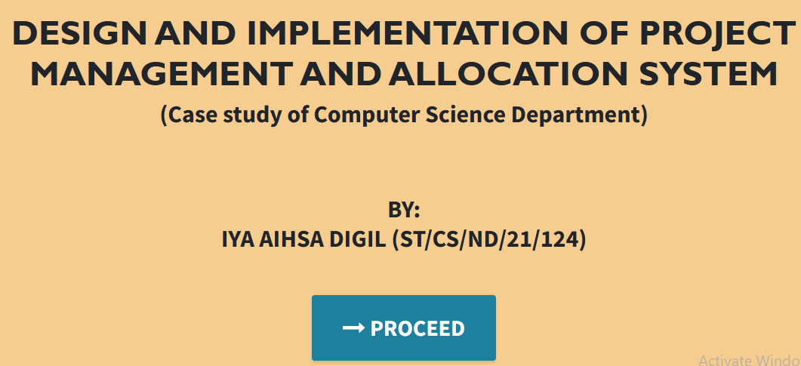

Figure 4.1: Welcome Interface

Login interface

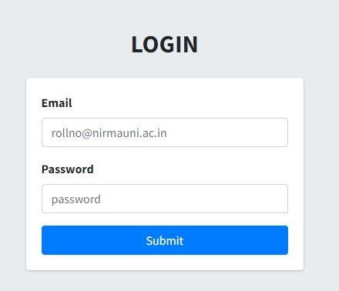

Figure 4.2: Login page interface

Add Student interface

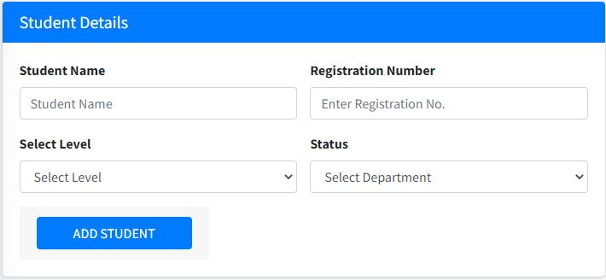

Figure 4.3: Add Student interface

Register project topic interface

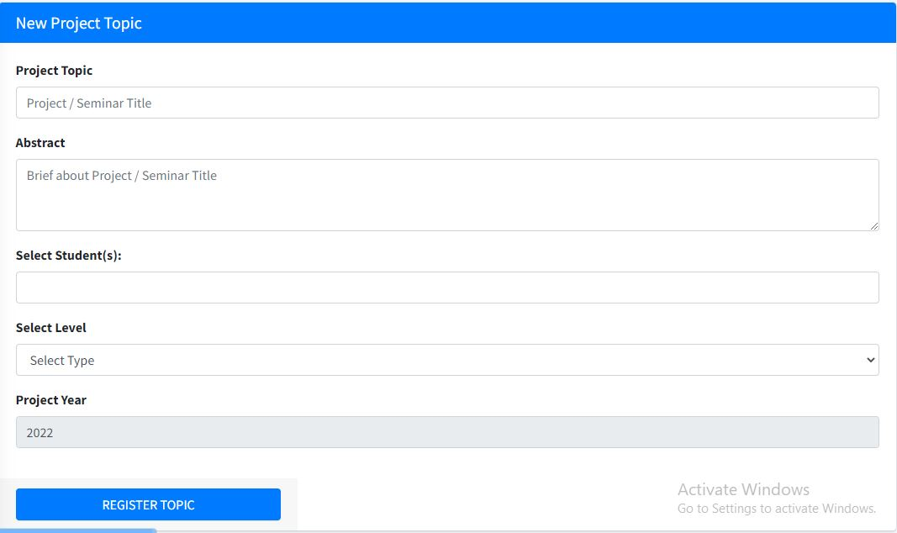

Figure 4.4: Register project topic

Registered project topics

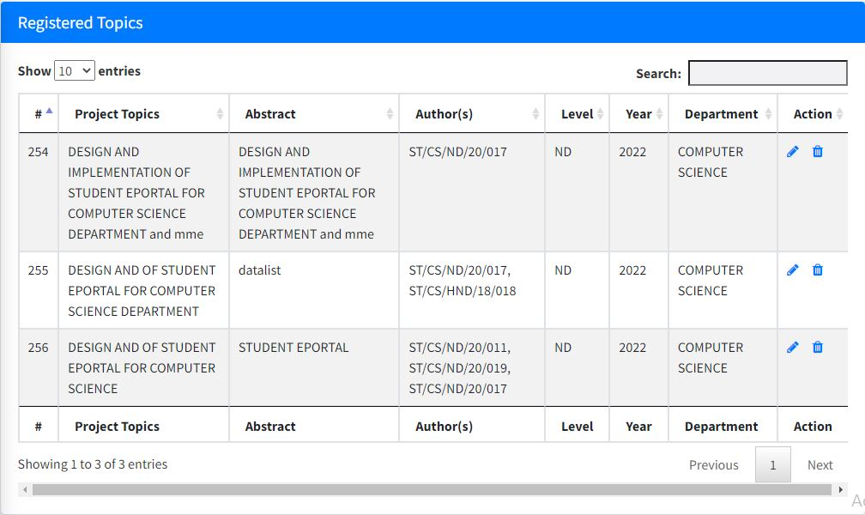

Figure 4.5: Registered project topics

Registered students interface

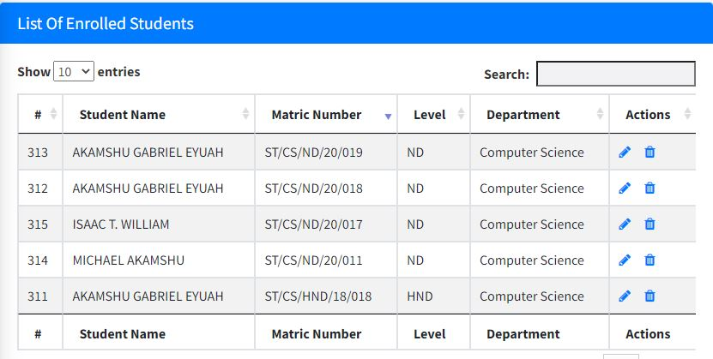

Figure 4.6: Registered students interface

## 4.3 Discussion

Figure 4.1 Welcome interface is the first interface that the user will see, it contains the project topic, student and the supervisor of the project.

Figure 4.2 Login interface is used by an existing admin to login into the system before completing any operation.

Figure 4.3 Add Student interface is used to add or register new students into the system.

Figure 4.4 Register project topic interface is used by the project coordinator to register project topics presented by particular students.

Figure 4.5 Registered project topics interface displays all the registered project topics currently in the system

Figure 4.6 Registered students’ interface displays all the registered students currently in the system

## 4.4 User manual

The user manual is a clear and precise instruction on how a user can operate the propose system, without any stress and successful. The following steps required

1. Start or boot the computer form the hard disk
2. Double click on the folder that program is been stored in the desktop
3. Double click on the program and allow it to load gently
4. A security unit will display were the user will specify the user name and password the click on OK.
5. A welcome menu will be displayed where the user has options to select which operation to be performed.
6. To find information about player, select any name and search.
7. Click on exist on the welcome screen to exist from the program.

The following are the necessary steps to take in order to use the system efficiently and effectively.

1. Load the url of the system <https://localhost/project/> the welcome page will be displayed.
2. Click on the **Proceed** button to proceed to the main system.
3. Provide the login details by entering your username and password.
4. The various task that you can perform on the portal will be displayed on the sidebar of the dashboard.

# CHAPTER FIVE

# SUMMARY, CONCLUSION AND RECOMMENDATIONS

## 5.1 Summary

The project, "Design and Implementation of Project Management and Allocation System," conducted as a case study within the Computer Science Department, represents a significant advancement in enhancing the efficiency and effectiveness of project management and resource allocation within the academic setting. This summary provides an overview of the project's key findings, outcomes, and implications.

## 5.2 Conclusion

In conclusion, the implementation of the Project Management and Allocation System has yielded promising results and improvements in the management of projects and resources within the Computer Science Department. It has streamlined the allocation of projects to students, faculty, and resources, resulting in better utilization of resources, improved project tracking, and enhanced collaboration. The successful implementation underscores the importance of such systems in academic settings, paving the way for potential adoption in other departments and institutions.

## 5.3 Recommendations

Based on the findings and experiences gained from the implementation of the Project Management and Allocation System, several recommendations are proposed:

1. Scaling and Adoption: Consider scaling the system for broader departmental or institutional use, extending its benefits to other departments and faculties.
2. User Training: Provide comprehensive training to faculty, staff, and students to maximize the system's utilization and ensure that all stakeholders can effectively use its features.
3. Continuous Improvement: Establish a feedback mechanism for users to suggest improvements and additional features for future iterations of the system.
4. Security and Data Protection: Strengthen security measures to protect sensitive project and student data, ensuring compliance with data protection regulations.

## 5.4 Contribution to Knowledge

This project contributes to the body of knowledge in project management and academic resource allocation within the field of computer science and beyond. It demonstrates the feasibility and advantages of using technology-driven solutions to optimize project allocation and management in educational settings. Additionally, the project serves as a practical case study for implementing similar systems in other academic institutions, fostering the dissemination of best practices.

## 5.5 Area for Further Work

While the Project Management and Allocation System has achieved notable success, there remain areas for further research and improvement. Future work could explore:

Enhanced Features: Developing advanced features such as automated project evaluation, real-time analytics, and integration with external project management tools.

Cross-Department Implementation: Extending the system's implementation to other departments and faculties to assess its broader impact and adaptability.

User Experience Studies: Conducting user experience (UX) studies to refine the system's interface and usability based on user feedback.

Long-Term Impact Assessment: Monitoring the long-term impact of the system on project outcomes, student performance, and resource allocation efficiency.

**References**

Bala, R., Sridharan, R., & Fong, A. C. (2020). Intelligent project allocation using data mining techniques. *Computers & Education*, 153, 103901.

Chen, Y., Gao, M., Xu, B., Ma, H., & Gu, X. (2021). A web-based project management platform for enhancing computer science education. *Proceedings of the 2021 4th International Conference on Education and Multimedia Technology (ICEMT),* 69-73.

Chen, Z., Tang, L., Chen, Y., & Wang, F. (2020). Genetic algorithm-based project allocation in computer science education. *Journal of Computers in Education*, 7(3), 415-431.

Crouch, C. H., & Mazur, E. (2001). Peer instruction: Ten years of experience and results. *American Journal of Physics*, 69(9), 970-977.

Dasgupta, S., Krishnamoorthy, M., & Nagarajan, V. (2017). Multi-objective optimization for student-project allocation. *Proceedings of the 2017 IEEE Congress on Evolutionary Computation (CEC)*, 2527-2534

Dianiška, O., Chudý, P., Baračkay, M., & Csóka, L. (2022). Project management system for engineering education. *International Journal of Engineering Education*, 38(1), 36-46.

Guzdial, M. (2018). Paving the way for computational thinking. *Communications of the ACM*, 51(8), 25-27.

Li, X., Li, B., & Gu, X. (2019). A project management system for enhancing engineering education. *IEEE Transactions on Education*, 62(4), 289-296.

Liu, Y., Li, X., Gu, X., & Hu, Y. (2021). A project allocation model based on random forest algorithm. *International Journal of Emerging Technologies in Learning*, 16(13), 205-220.

Simsek, A., Demir, H., & Ozbek, S. (2020). Project management system for business schools. *European Journal of Engineering Education*, 45(3), 404-420.

Wang, C., Sun, Y., & Yin, J. (2021). A project management system for computer science education. *International Journal of Emerging Technologies in Learning*, 16(7), 188-202.

Xu, B., Gao, M., Chen, Y., & Gu, X. (2022). Deep learning-based project allocation model for computer science education*. IEEE Transactions on Education*, 65(1), 64-73.

Zhu, X., Guo, L., Li, Y., & Yang, H. (2020). Multi-objective project allocation algorithm for computer science education. *International Journal of Emerging Technologies in Learning,* 15(15), 167-183.

# APPENDIX A

Welcome interface



Login interface



Add Student interface



Register project topic interface



Registered project topics



Registered students interface



# APPENDIX B

**PROGRAM CODE**

<!DOCTYPE html>

<html>

<head>

    <title><?php echo PROJECT_NAME; ?></title>

    <link rel="stylesheet" type="text/css" href="css/bootstrap.min.css">

    <link rel="stylesheet" type="text/css" href="css/style.css">

    <link rel="stylesheet" type="text/css" href="//cdnjs.cloudflare.com/ajax/libs/jquery-jgrowl/1.4.1/jquery.jgrowl.min.css" />

    <link rel="stylesheet" type="text/css" href="https://maxcdn.bootstrapcdn.com/font-awesome/4.7.0/css/font-awesome.min.css">

    <link rel="stylesheet" type="text/css" href="https://cdn.datatables.net/1.10.16/css/dataTables.bootstrap.min.css">

    <link rel="stylesheet" type="text/css" href="https://maxcdn.bootstrapcdn.com/font-awesome/4.7.0/css/font-awesome.min.css">

    <script src="js/jquery.js"></script

</head>

<?php

require 'init.php';

?>

<?php include 'head.php'; ?>

<body background="image/bg2.jpg">

   <div class="container start-container">

     <div class="col-md-6 title-text">

         <img src="image/polylogo.png" class="img-rounded img-responsive" width="100" height="100">

      <h4>The Polytechnic, Ibadan</h4>

      <h1>STUDENTS' PROJECT ALLOCATION & MANAGEMENT SYSTEM</h1>

     </div>

     <div class="col-md-4">

      <?php include 'login_form.php'; ?>

     </div>

   </div>

<?php include 'footer.php'; ?>

<table class="table table-bordered table-hover project_table">

    <thead>

        <tr>

            <th>Project Name</th>

            <th>Project Case</th>

            <th>Project Level</th>

            <th>Allocation Status</th>

            <th>Option</th>

        </tr>

    </thead>

    <tbody>

        <?php

           $query = $db->query("SELECT * FROM project");

             $rows = $query->fetchAll(PDO::FETCH_OBJ);

             foreach($rows as $row){

               $project_name = $row->project_name;

               $project_case = $row->project_case;

               $project_level = $row->project_level;

               $allocation = $row->allocation;

        ?>

             <tr>

                <td><?php echo $project_name; ?></td>

                <td><?php echo $project_case; ?></td>

                <td><?php echo $project_level ?></td>

                <td><?php echo ($allocation == 0)? '<label class="text-success">Available</label>':'<label class="text-danger">Unavailable</label>' ?>

                </td>

                <td>

                    <a class="btn btn-xs btn-primary" href="editproject.php?id=<?php echo $row->id; ?>"><i class="fa fa-edit"></i></a>

                      <a class="btn btn-xs btn-danger" onclick="return confirm('Are you sure you want to delete project? ')" href="deleteproject.php?id=<?php echo $row->id; ?>"><i class="fa fa-trash"></i></a>

</table>

<table class="table table-bordered table-hover project_table">

    <thead>

        <tr>

            <th>Student Name</th>

            <th>Matric</th>

            <th>Level</th>

            <th>Department</th>

      <th>Date Added</th>

            <th>Option</th>

        </tr>

    </thead>

    <tbody>

        <?php

           $query = $db->query("SELECT * FROM student");

             $rows = $query->fetchAll(PDO::FETCH_OBJ);

             foreach($rows as $row){

               $name = $row->name;

               $department = $row->department;

               $level = $row->level;

               $matric = $row->matric;

               $date = $row->date;

        ?>

             <tr>

                <td><?php echo $name; ?></td>

                <td><?php echo $matric; ?></td>

                <td><?php echo $level ?></td>

              <td><?php echo $department ?></td>

              <td><?php echo $date; ?></td>

                <td>

                    <a class="btn btn-xs btn-primary" href="edit_std_data.php?id=<?php echo $row->id; ?>"><i class="fa fa-edit"></i></a>

                      <a class="btn btn-xs btn-danger" onclick="return confirm('Are you sure you want to delete project? ')" href="delete_std_data.php?id=<?php echo $row->id; ?>"><i class="fa fa-trash"></i></a>

                </td>

             </tr>

        <?php

           }

        ?>

    </tbody>

</table>

<?php require 'init.php'; ?>

<?php include 'head.php'; ?>

<body>

<?php include 'dashboard_navbar.php'; ?>

<h3>Recent Project Allocations</h3>

<div class="table-responsive">

    <table class="table table-bordered table-striped table-hover project_table">

        <thead>

            <tr>

                <th>ID</th>

                <th>Student Name</th>

                <th>Project Title</th>

                <th>Case Study</th>

                <th>Level</th>

                <th>Department</th>

                <th>Matric. NO</th>

            </tr>

        </thead>

        <tbody>

            <?php

             $query = $db->query("SELECT * FROM student");

             $rows = $query->fetchAll(PDO::FETCH_OBJ);

             foreach($rows as $row){

               $name = $row->name;

               $matric = $row->matric;

               $level = $row->level;

               $department = $row->department;

               $project_id = $row->project_id;

               $date = $row->date;

               $id = $row->id;

               $run = $db->query("SELECT project_name,project_case FROM project WHERE id = '$project_id'");

               $run_rows = $run->fetchAll(PDO::FETCH_OBJ);

               foreach($run_rows as $runrow){

                  $case = $runrow->project_case;

                  $title = $runrow->project_name;               <td><?php echo $id; ?></td>

                <td><?php echo $name; ?></td>

                <td class="text-bold"><?php echo $title; ?></td>

                <td class="text-bold"><?php echo $case; ?></td>

                <td><?php echo $level; ?></td>

                <td><?php echo $department; ?></td>

                <td><?php echo $matric; ?></td>

               </tr>

               <?php

               }

             }

            ?>

        </tbody>

    </table>

</div>

<?php include 'footer.php'; ?>